*DIGISIM*

***Digi****tal image based* ***Sim****ulation Toolbox*

*Version 1.0 User Manual*



Qing-Xiang Meng

Department of Civil Engineering

In Hohai University

Nanjing, China 210098

March 2019

1. Introduction

DigiSim is an open source software package for digital image processing based micromechanical Simulation. It is an easy, user-friendly and ready-to-use software developed using Matlab. The main object of this code is to model the micromechanical behavior of heterogeneous material based on the image captured by CT, MRI or digital camera. Both FEM and DEM model can be generated using DigiSim package. Besides, it also can be employed to extract the microstructure of material like inclusions, pores and cracks. The basic calculation flow of DigiSim is described in Fig.1 and a brief program summary of the package is as follows:

*Licensing provisions*: GNU General Public License, version 3

*Programming language*: Matlab (2016 & 2017)

*Computer*: Any workstation or laptop computer with Matlab

*Operating system*: Linux, Windows, or Mac OS X

Start binary image read

CCL implementation

BET implementation

Bitmap

vectorization

Boundary refinement

Geometry Scaling

Size & direction

Area

MBR

Geometric

statistics

Statistical analysis

Geometry Output

Numerical Model

Generation

DEM packing

FEM mesh

End Program

Fig. 1 General flowchart for DigiSim software package

2. Basic Procedure

2.1 Digital image Preparation

Most digital image is color or gray graph, and it cannot be directly used in DigiSim. An image binaryzation process is employed to distinguish the microstructure. For some pictures with clear difference like Fig.2a, a threshold value can be used directly to get the binary image. Otherwise, some complex process or image software like Photoshop is in demand (Fig.2b). The ‘JPG’ file format is recommend in DigiSim.

|  |  |
| --- | --- |
|  |  |
|  | I:\论文写作\7 离散元数字图像\I.jpg |
| (a) CT image | (b) digital camera image |

Fig. 2 Image binaryzation of color image

2.2 DigiSim Execution

After the binary image is obtained, we can run DigiSim to analyze the microstructure. Two run modes are provided in the package. One is GUI mode and the other is script mode. For users who are not familiar with MATLAB, GUI mode is recommended. Otherwise, script mode is preferred.

Thanks to the valuable comments of two reviewers, this code is imroved a lot and some new features are added. We suggeste the users use script mode and run the example*.m file. GUI mode is only for the first two example. We will update the GUI mode soon.

2.2.1 GUI Mode

(1) Open the file folder of Digisim and just write DigiSim in Command window (Fig.3a) and a pop-up window will appears like Fig.3b. There are 5 parameters, boundary refinement parameter is the threshold distance in Algorithm 3 in the paper. Scale factor is the resolution of one pixel. Matrix and microstructure mesh size are the seed distance of FEM. Ball radius is the size of particle in DEM model.

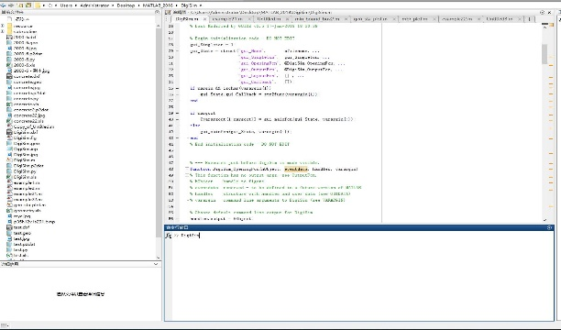 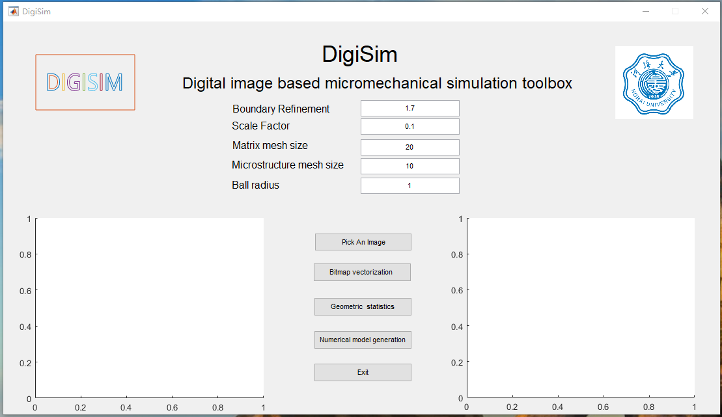

Fig. 3 Open DigiSim GUI

After setting the 5 parameters, we can click the option of “Pick An Image”, a select window will appear and we can select the binary picture. The image will appear in the left.

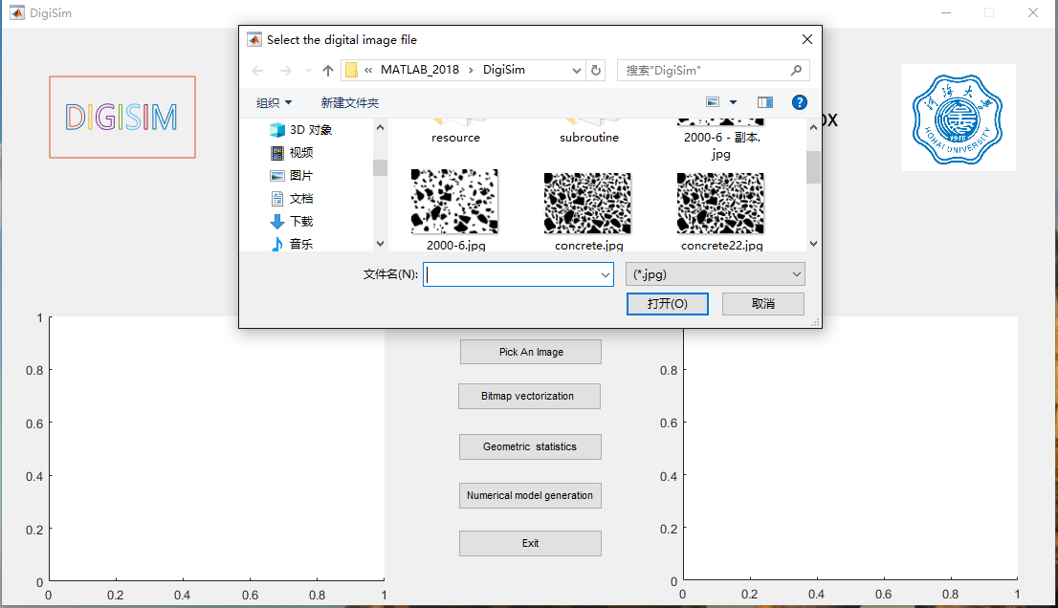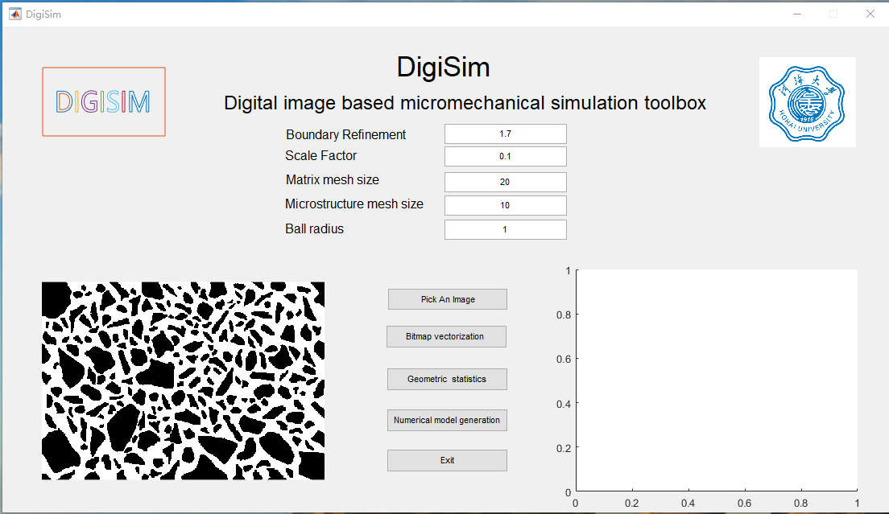

Fig. 4 Pick up the binary image

After select the picture, we can click “Bitmap Vectorization” option and the name will change to “Please Waiting”. After the process finished, the name will become “Finish” and the polygon geometry will appear at the left window.

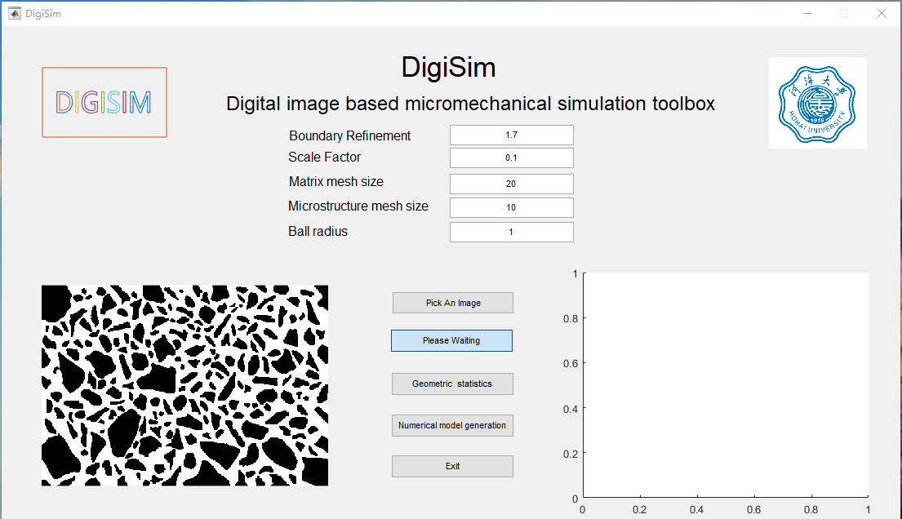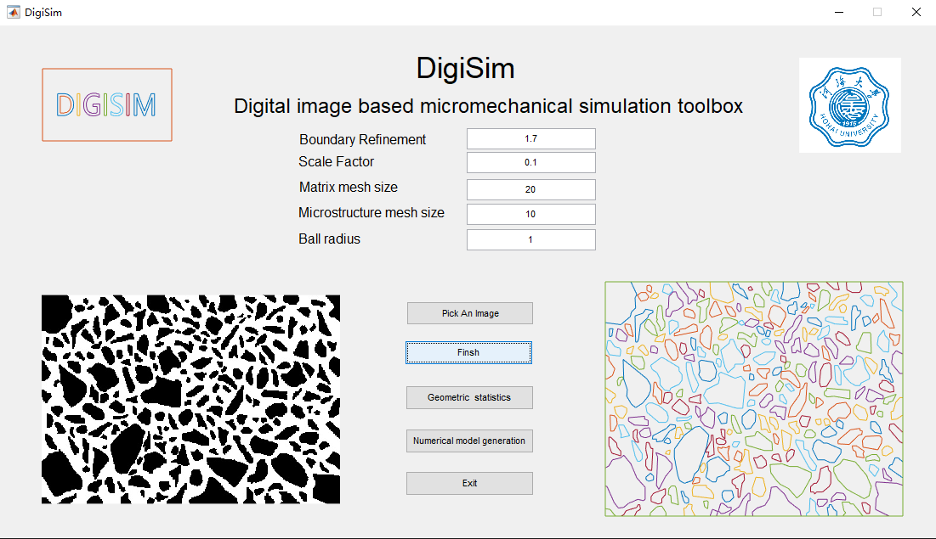

Fig. 5 Bitmap vectorization with DigiSim

After get the vector geometry of microstructure, we can click the “Geometric Statistics” option. And after the state change to “Finish”, an “xls” file will generate to record the geometry information.

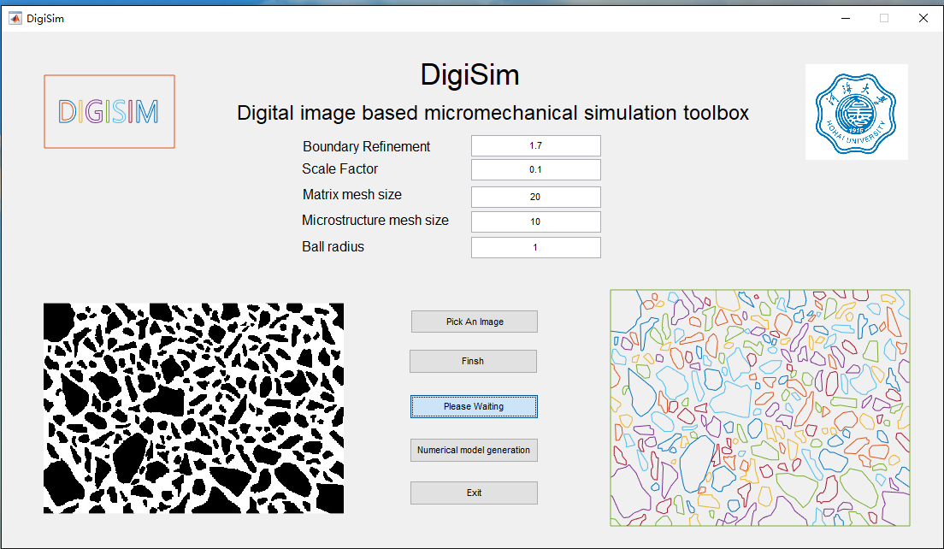 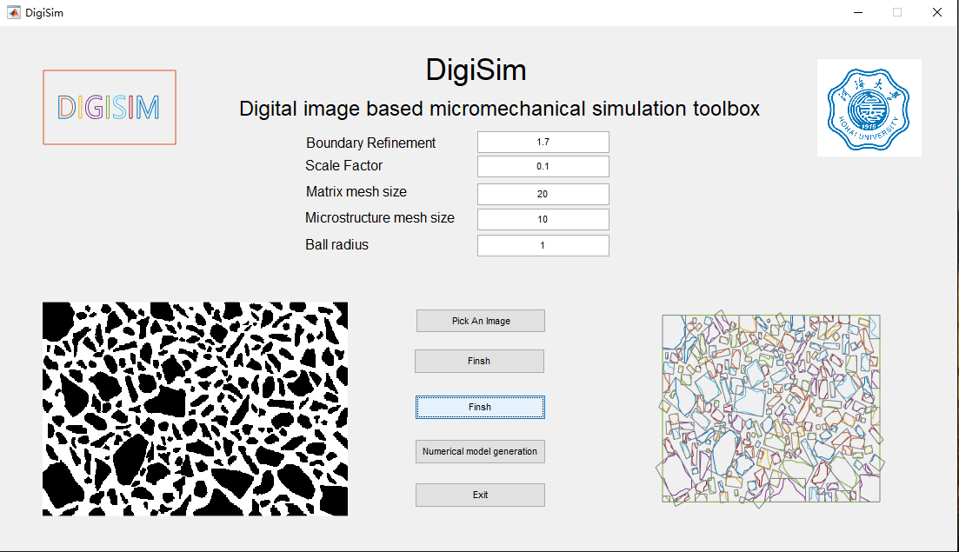

Fig. 6 Geometric statistics of microstructure

Then we can click the “Numerical model generation” option. After the state change to “Finish”, several new file will generate in the same file folder. The “dxf” file is the polygons for AutoCAD. The “geo” and “py” are scripts for gmsh and ABAQUS. The “p2dat” file is for PFC.

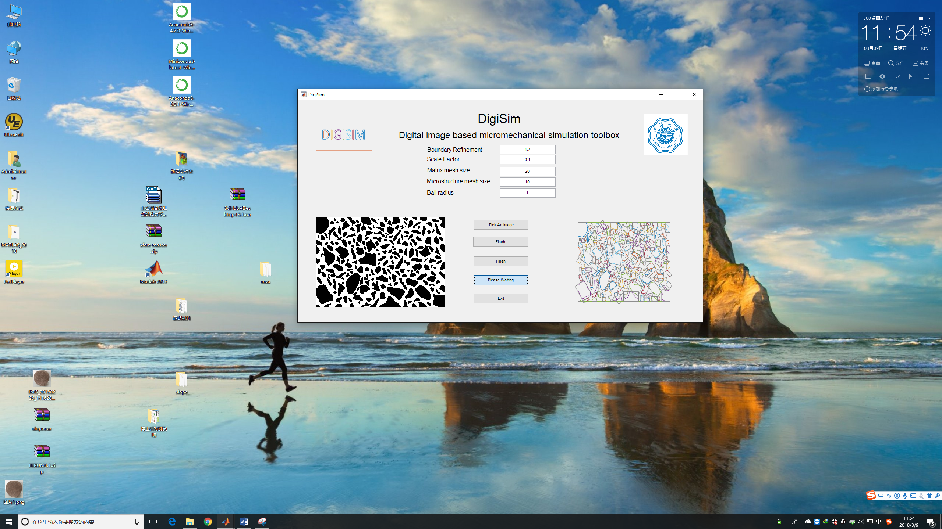 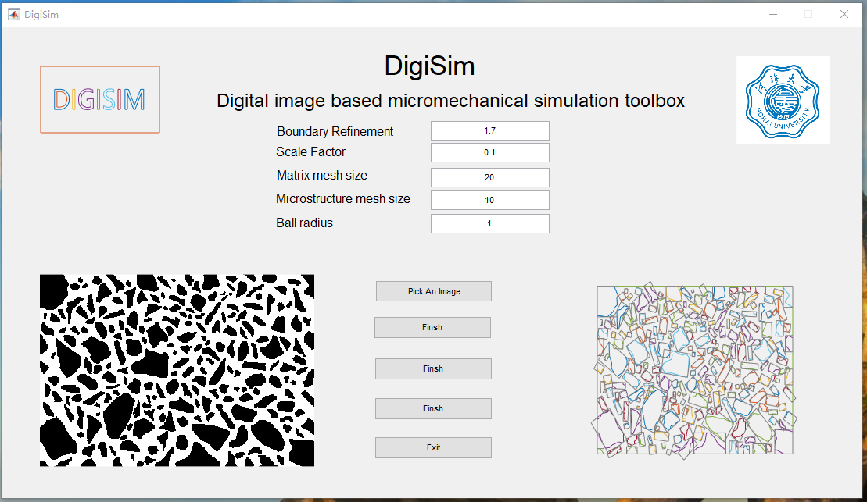

Fig. 7 Generation of numerical model

2.2.2 Script Mode

Script model is preferred for users familiar with MATLAB. A typical “.m” file is shown as follows:

1. clear;clc;
2. tic;
3. addpath subroutine
4. % set the image
5. image_file='concrete.jpg'; % image_file='DigiSim.jpg';
6. fn=image_file(1:length(image_file)-4);
7. % Vectorization bitmap
8. error=1.4;  scale=1/10;
9. [ P] = vectorization2(image_file,error);
10. P=geom_scale(P,scale);
11. figure(1);
12. geom_plot(P);
13. % Geometry information statistics
14. [parea,fraction]=geom_area(P);
15. mg=min_bound_box2(P);
16. mbr_plot(mg);
17. geo_file='geometry.xls';
18. geom_stas(geo_file,parea,fraction,mg,P);
19. geo_sta_plot(mg,parea);
20. % Geometry and mumerical model OutPut
21. dxf_file=[fn,'.dxf'];
22. dxf_file_write(P,dxf_file);
23. gmsh_file=[fn,'.geo'];
24. lc=5;lc2=10;
25. gmsh_file_write(P,gmsh_file,lc,lc2);
26. abaqus_file=[fn,'.py'];
27. write_abaqus_2d(abaqus_file,P);
28. pfc_file=[fn,'.p2dat'];
29. radius=1;
30. write_pfc_2d_group(P,radius,pfc_file);
31. % **if** Gmsh is sucessfully installed
32. % inp_file=[fn,'.inp'];
33. % str=['system(''gmsh.exe ',gmsh_file, '  -o ',inp_file,' -2'');']; eval(str);
34. % **if** Abaqus is sucessfully installed
35. % str=['system(''abaqus cae noGUI=',abaqus_file,''');'];eval(str);
36. toc;

If you want to analyze new digital images, you can just change the image_file to your file. Five parameters in the GUI mode have the variable name “error”, “scale”, “lc”, “lc2” and “radius” correspondingly. Also if the Abaqus and Gmsh is properly installed on the computer and we can simply cancel the comment of the line 32,33 and 35. Two examples is provide in the software package and the user can run the code “example1.m” or “example2.m” to demonstrate the digital image processing based modeling easily.

3. API reference

The DigiSim package is still under development and more new features will be appear in the near future. Now, DigiSim package have 30 functions and the function description is shown in Table 1. If you have any problems of DigiSim, feel free to contact the author.

Table 1 Functions of DigiSim software

|  |  |
| --- | --- |
| Function | Description |
| axis_length_direction | Calculate the axis and length of long axis |
| ball_generate | Generate the balls for DEM model |
| boundary_smooth | Boundary refinement for polygon |
| classify_poly5 | Classify the inclusion polygons |
| dis_cal | Calculate the distance of a point to line |
| geom_area | Calculate the area of polygon |
| geom_axis | Calculate the axis of polygon |
| geom_plot | Plot the geometry information |
| geo_sta_plot | Plot the geometry statistics information |
| geom_scale | Scaling the geometry with |
| geom_stas | Calculate the geometry statistics information |
| gmsh_file_write | Write the polygon information to Gmsh |
| gmsh_write4 | Polygon information to Gmsh |
| judge_bou2 | Whether a line at boundary |
| mbr_plot | Plot the minimum bound box |
| min_bound_box2 | Calculate the minimum bound box of all polygons |
| minBoundingBox | Calculate the minimum bound box of a polygon |
| out_line | Get the polygon line at the boundary |
| panduan_in | Judge a line in the line set |
| sort_boun | Get the line at the boundary |
| sort_line | Generate the polygon with lines |
| sort_line_mod2 | Refine the boundary polygon |
| vectorization2 | Binary image vectorization |
| write_abaqus_2d | Write the geometry to ABAQUS |
| dxf_file_write | Write the geometry to AutoCAD |
| write_dxf_end | Function for writing dxf |
| write_dxf_head | Function for writing dxf |
| write_dxf_line | Function for writing dxf |
| write_dxf_poly_line | Function for writing dxf |
| write_pfc_2d_group | Regroup the DEM model |